Resources for Learning and Practicing Java Programming.
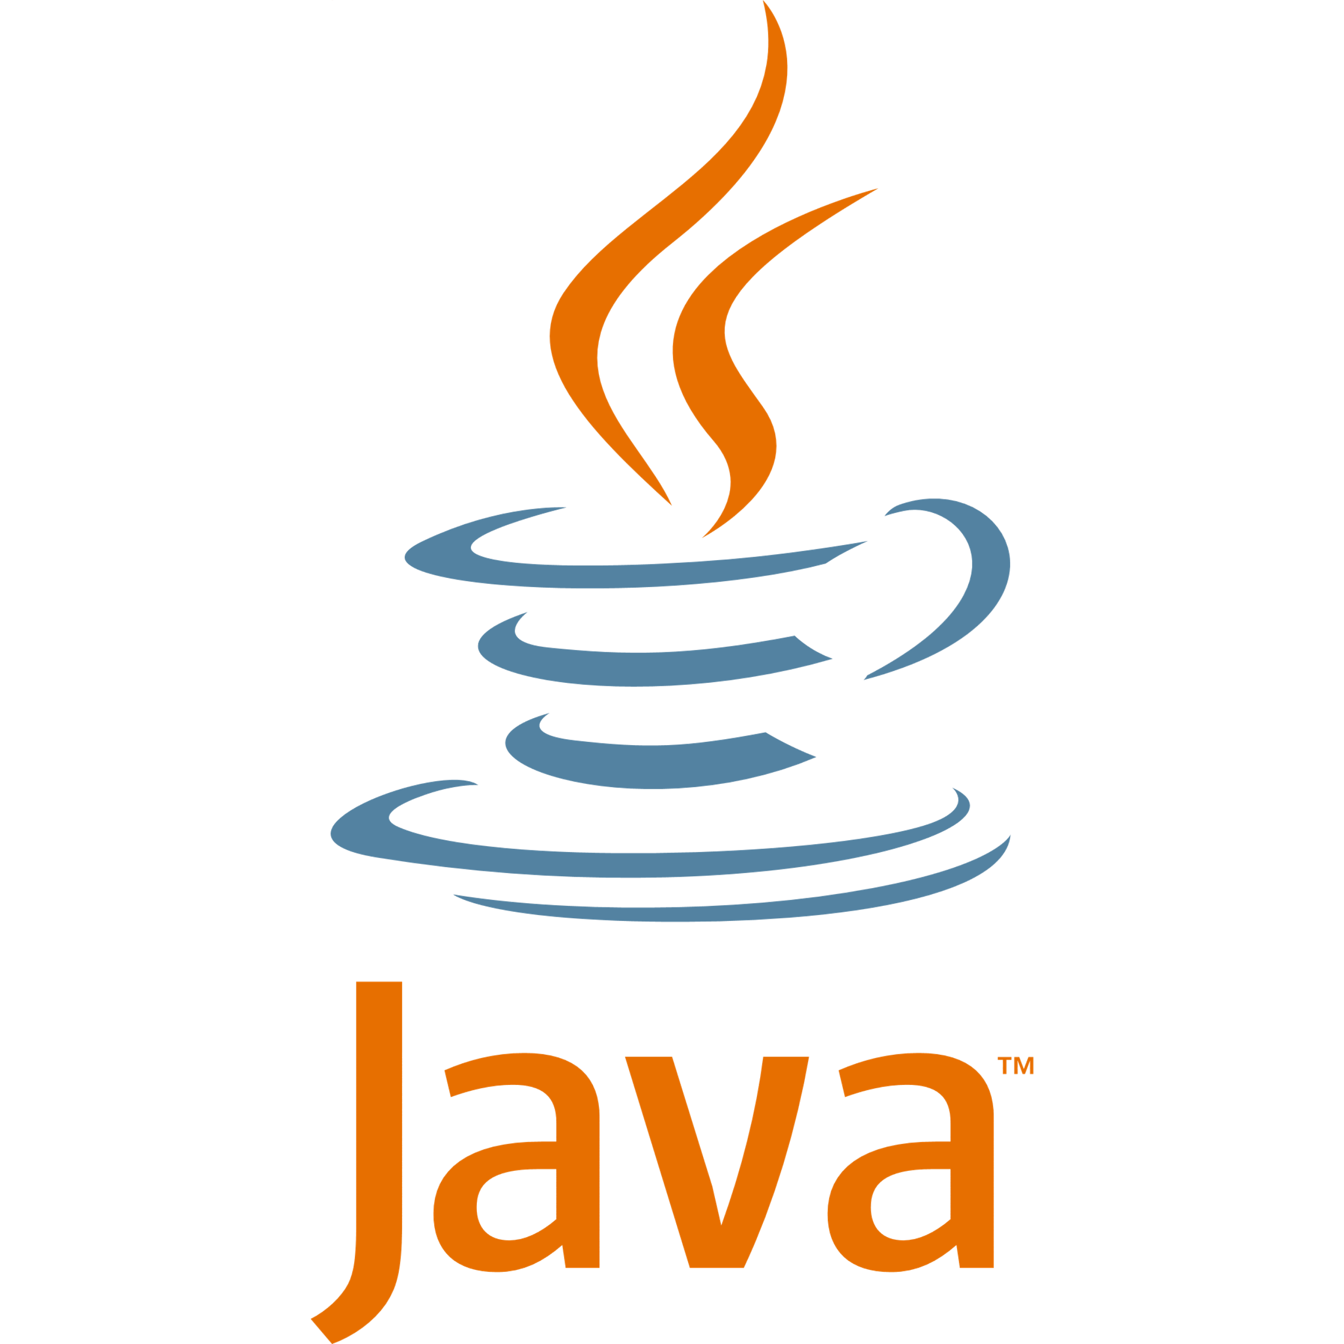
Java is more than just a programming language. Want to build apps, games, or even software used by millions? It's the foundation of countless apps, websites, and technologies we use every day.

1. Official Documentation and Websites:
- Oracle Java Documentation
Oracle Java Documentation is the official guide created by Oracle, the company that develops and maintains Java. It is mainly about helping programmers learn, understand and use Java correctly. It includes:
- Java tutorials for beginners and advanced learners.
- API documentation that explains Java classes, methods, and packages.
- Installation guides for the Java Development Kit (JDK).
- Code examples and programming best practices.
- Information about new Java features and updates.

- OpenJDK
OpenJDK (Open Java Development Kit) is the free, open-source implementation of the Java Platform. It includes the Java compiler, Java Virtual Machine (JVM), and standard libraries required to develop and run Java applications. It is widely used by students, developers, and organizations because it is regularly updated and follows official Java standards.
2. Books and E-Books:
- Java: The Complete Reference (12th Edition) – Herbert Schildt.
This is a comprehensive guide to Java programming. It covers both basic and advanced topics, including collections, multithreading, networking, GUI development, and Java APIs. It is suitable for students as well as professionals.
Official Link:https://www.mheducation.com/highered/mhp/product/java-complete-reference-thirteenth-edition.html?view Option=student

- Core Java, Volume I – Fundamentals (12th Edition) – Cay S. Horstmann
This book focuses on building a strong foundation in Java. It explains core concepts such as variables, loops, classes, interfaces, exceptions, and collections with clear examples. It is highly recommended for beginners and intermediate learners.
Official Link https://www.oreilly.com/library/view/core-java-volume/9780137673810/

3. Online Learning Platforms:

Online learning platforms provide structured courses, coding exercises, quizzes, and projects that help students learn Java effectively.

- LinkedIn Learning
LinkedIn Learning provides professional Java courses taught by experienced instructors. The platform includes beginner-friendly lessons, coding demonstrations, and completion certificates.

- By experienced instructor

Venkat Subramaniam (Founder of Agile Developer, Inc.)- An internationally recognized Java instructor who teaches Java, Spring, and software development.

Official Website: https://agiledeveloper.com/

- Free Code Camp
Free Code Camp offers free programming tutorials, Java-related learning resources, and project-based coding practice. It is an excellent platform for self-paced learning.

4. Coding Practice Websites

Hacker Rank
Hacker Rank provides Java programming challenges, coding competitions, and interview preparation questions. It helps improve problem-solving skills.

Leet Code
Leet Code contains hundreds of Java coding problems that are useful for technical interview preparation and algorithm practice.

Code forces
Code forces hosts regular programming contests and practice problems that help programmers improve their coding speed and logical thinking.
5. Community & Discussion Forums:

Stack Overflow
Stack Overflow is one of the largest programming communities where Java developers ask questions, share solutions, and discuss programming issues.
- GitHub Discussions
Many Java open-source projects host discussions where developers ask questions, report issues, and collaborate on Java-related topics.
- Oracle Java Community
The official Java community where developers can find announcements, discussions, and resources related to Java technologies.
"My Preferred Resources"
I personally prefer learning from an experienced instructor because I believe that live lectures and guided explanations are the most effective way to understand Java concepts.
For practicing programming, I prefer Leet Code because it offers problems ranging from easy to hard, which helps me improve my coding and problem-solving skills step by step.
For discussions and updates, I prefer Stack Overflow and GitHub because I am active on both platforms. Stack Overflow helps me find solutions to programming problems, while GitHub allows me to explore projects, learn from other developers, and stay updated with new Java technologies.

